Hi Fhon,
Thank you for sharing the great news from the Royal Academy of Engineering. I also wanted to update you that I have now prepared the complete project folder, which includes:
- Training folder for TrOCR Optical Character Recognition
- Evaluation results with the Excel summary sheet
- YOLO_trained_fixed_seed model
- YOLO_trained_optuna model
- best_trocr_v1 trained model
- All datasets used for the JLR VIN number plate project
All supporting files have been included, such as the README, requirements.txt, and configuration files, so the pipeline can be fully reproduced without any issues.
For re-running the workflow, please ensure the following steps:
- Install all required libraries using the included requirements.txt file.
  - Current environment versions:
    - CUDA 11.8
    - Python 3.11.5
- Recreate the data.yaml file when preparing the dataset again.
- If the project folder is moved to a different location on the PC, remember to update all relevant paths in:
  - data.yaml
  - Any scripts containing absolute directory references
Everything has been organised so that Olu or anyone else can easily replicate the training and evaluation steps simply by following the README.
If you need any further details or would like me to walk through the setup with the team, I’m happy to help.
Link:https://ydray.com/get/t/u1764940832143SopN7b793b7469feWP
Kind regards,
Prabhath
Hi. Fhon,
I hope you are well.
I would like to share the latest results from the VIN detection and recognition experiments. As requested, I have rerun the TrOCR evaluation and consolidated the outcomes from all three pipelines: YOLOv8s (fixed seed), YOLOv8s + Optuna, and TrOCR.
Summary of Methods Tested
1. YOLOv8s – Fixed Seed Training
- Standard YOLOv8s model with controlled randomness.
- Ensures reproducible bounding-box detection.
- Overall F1-score: 0.994
2. YOLOv8s – Optuna Hyperparameter Optimization
- Performed Optuna tuning for LR, momentum, augmentations, and optimizer settings.
- Improved training stability but results matched fixed-seed performance.
- Overall F1-score: 0.994
3. TrOCR (HuggingFace VisionEncoderDecoderModel)
- Used the fine-tuned TrOCR model for character-level recognition.
- Evaluated using a dedicated 160-image VIN test set.
- Files were cleaned, deduplicated, and processed once each.
TrOCR Results (160 Test Images):
- Correct: 158
- Failed: 2
- Accuracy: 98.75%
- Character accuracy: 99.93%
- F1 (micro): 0.9993
- F1 (macro): 0.9994
These results demonstrate that the TrOCR workflow is both highly accurate and consistent on the VIN dataset.
Video Demonstration
To make the evaluation process transparent, I recorded a short demonstration showing how the TrOCR tool processes all 160 test images:
Video link: https://ydray.com/get/t/u17649299687973yLXE977302ae6249kK
Documentation Delivery
As you requested, I will provide full documentation for all three systems:
- YOLOv8s fixed-seed
- YOLOv8s + Optuna optimization
- TrOCR VIN recognition pipeline
- Comparison tables and evaluation metrics
- Training logs and configuration files
Because I have a meetings with my PhD supervisors and infosys, I will send the complete documentation Friday night or Saturday at the latest.

Kind regards,
Prabhath Dissanayake
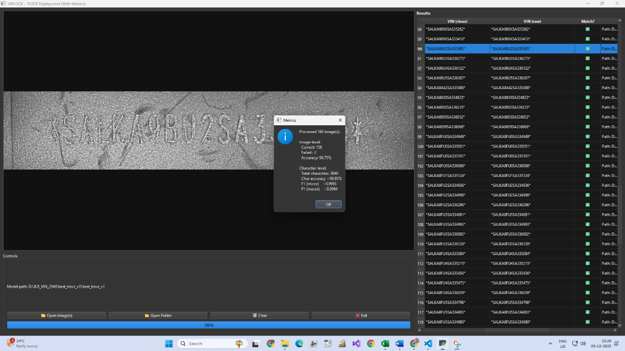

From: Oluwagbamila Feranmi <gbamilavictor@gmail.com>
Sent: 04 December 2025 08:59
To: fhon.supmak@oxfordvst.com <fhon.supmak@oxfordvst.com>
Cc: Dissanayake Dissanayake <dissanayad@uni.coventry.ac.uk>; gold okpa <okpagold@gmail.com>
Subject: Re: Subject: YOLOv8 Training Results – VNNumbers Dataset

Hello everyone, My name is Oluwaferanmi(Olu) and I am happy to be joining the team. This is a great opportunity and I am glad to be part of it.
So first thoughts are I am aligned with the progress of the project so far and believe we are doing good work.
Few concerns are we should be accurately engineering our processes. We should have a repo everyone can work from as it helps us track our changes which is more convenient.
Basically just a few structural modifications to the process to make it better streamlined and more cohesive.
I am working on a template we can follow to better improve our work structure when i get access to the codebase and will include detailed documentation.
As for improving the model i am happy to continue in the direction we have gone so far as i believe this approach and suggest possible solutions to get us to >99.
My apologies might not be able to come in this morning as still have to make some plans. I am happy to continue working as soon as i can get access to the code.
Thank you.

